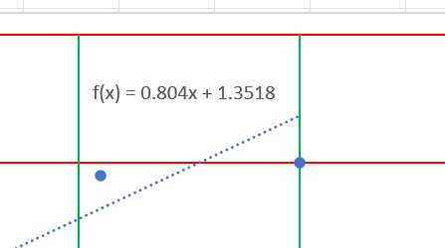
$$f\left(x_{i}\right)−y_{i}$$
$$F\left(y_{i}\right)−x_{i}$$

Figure 3: A data point with a fit line continued.

$$\sqrt{A^{2}{\left(f\left(x_{i}\right)−y_{i}\right)}^{2}+B^{2}{\left(F\left(y_{i}\right)−x_{i}\right)}^{2}}\left(1\right)$$

We want to find $A^{2}$ and $B^{2}$ so that the resulting orange line is ┴ to the trendline. For normalization, $A^{2}+B^{2}=1$
Simply note that the trendline slope is 0.804 in this example. The orange line $slope=\frac{−1}{0.804}$ so we are almost done. Slope is rise over the run, thus:
$$\frac{A^{2}{\left(f\left(x_{i}\right)−y_{i}\right)}^{2}}{B^{2}{\left(F\left(y_{i}\right)−x_{i}\right)}^{2}}=slope^{2}$$
$$\frac{A^{2}}{B^{2}}=slope^{2}∙\frac{{\left(F\left(y_{i}\right)−x_{i}\right)}^{2}}{{\left(f\left(x_{i}\right)−y_{i}\right)}^{2}}=C^{2}$$
$$\frac{A^{2}}{1−A^{2}}=C^{2}$$
$$A^{2}=\frac{C^{2}}{1+C^{2}}∧B^{2}=1−A^{2}$$

